1. **What’s the difference between checked exception and unchecked exception?**

Checked exception:

Is the exception that explicitly declared from the method using throws on the method signature.

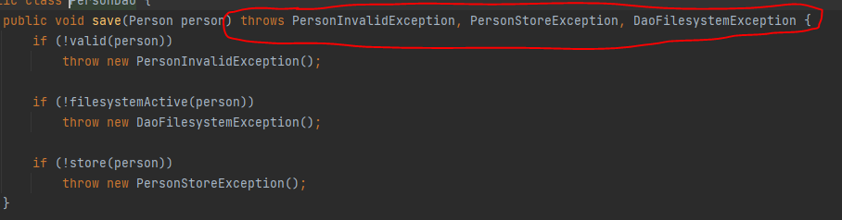

And must handle the exception on the caller:

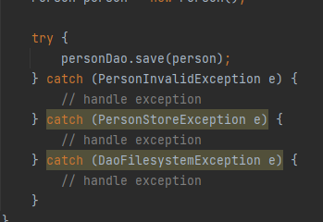

All checked exception extend java.lang.Exception except java.lang.RuntimeException

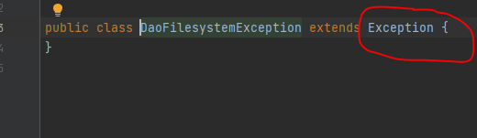

Unchecked exception:

Exception that happen during the runtime only.

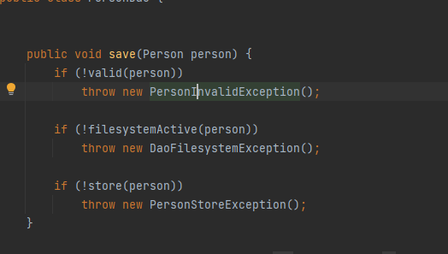

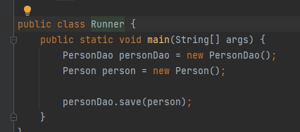

And all exception extends from Runtime exception

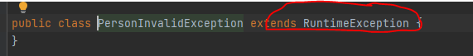

Unchecked exception does not occur during compilation time, only occur at runtime.

For DataAccess Exceptions:

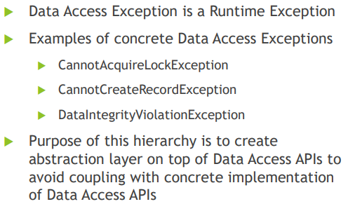

1. **How to configure data source in spring?**

To configure data source in Spring you need to create a @**Configuration** class that will return **javax.sql.DataSource** bean.

Note: that **javax.sql.DataSource** is an interface and the following classes implements this interface:

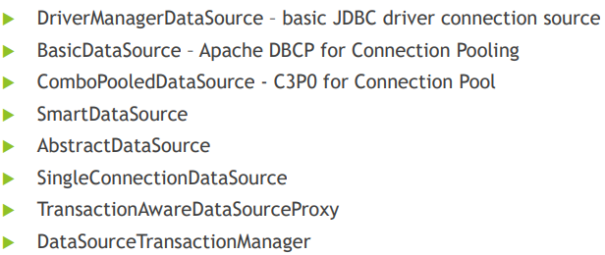

1. **Types of configuring Datasource in spring?**

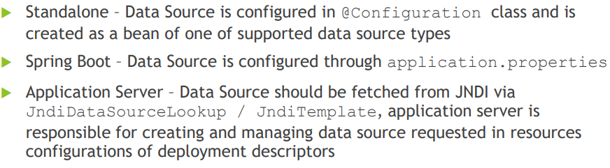

* Standalone:

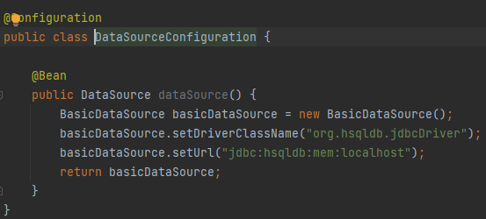

To initialize the data to datasourcethen we have DataSourceInitializer

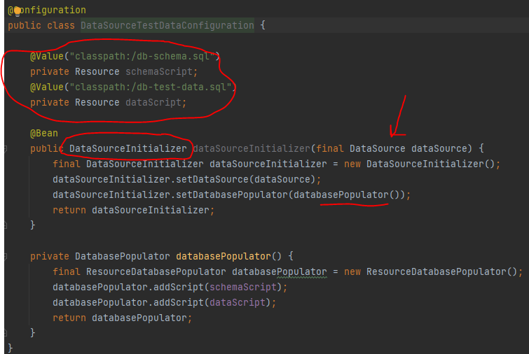

* springBoot:

u just need to add the config at application.properties file , and by default springBoot will load all .sql files in resource folder:

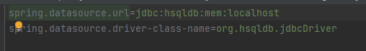

* for web application:

for web applications tomcat will first call class that Implement **WebApplicationInializer** OnStartup method.

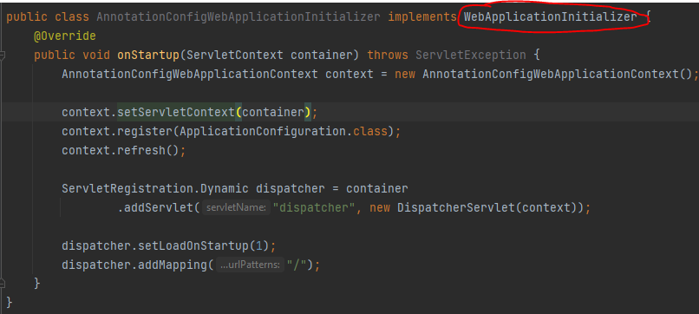

And them we have ApplicationConfiguration annotated with @componantScan that will load all @configuration annotation

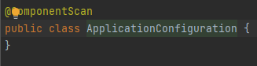

And inside DatasourceConfiguration we have jndi datasource

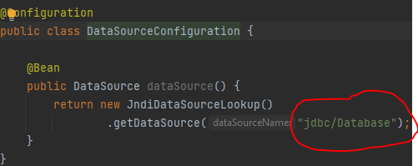

Note that jdbc/Database will be loaded from tomcat server config or from META-INF/context.xml

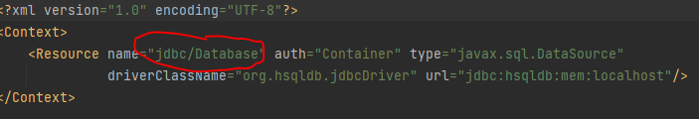

And to init the data then:

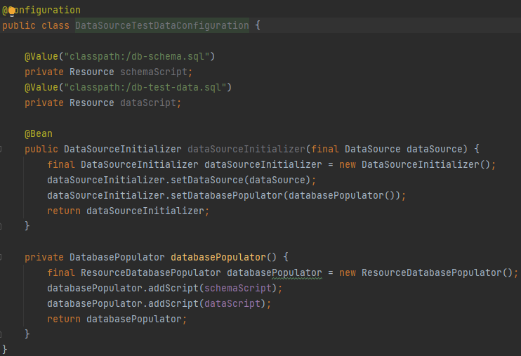

Then we can load the data from datasource:

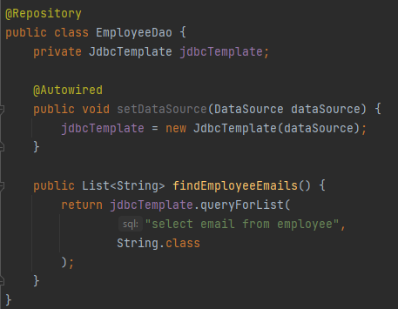

* using EmbaddedDatabaseBuild (this one for embedded database)

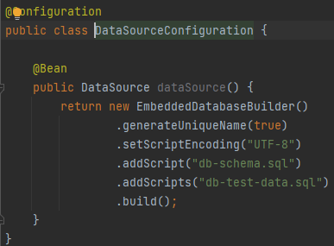

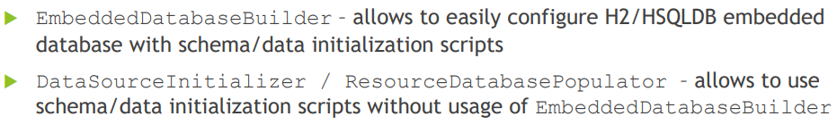

1. **What is Template design report?**

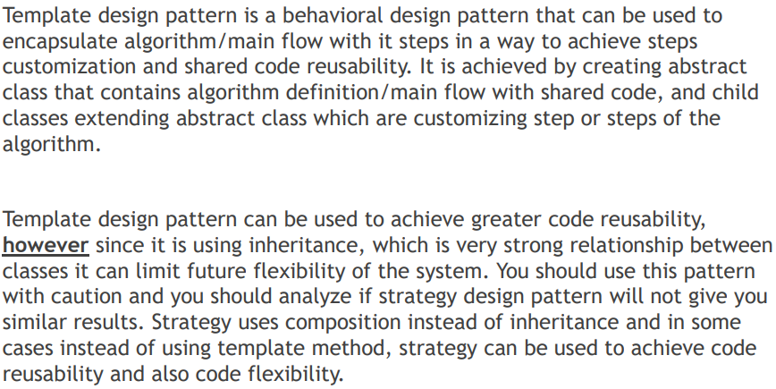

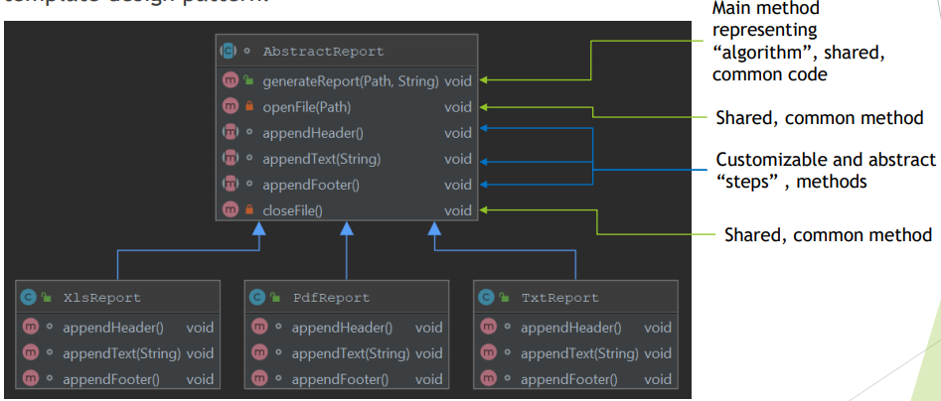

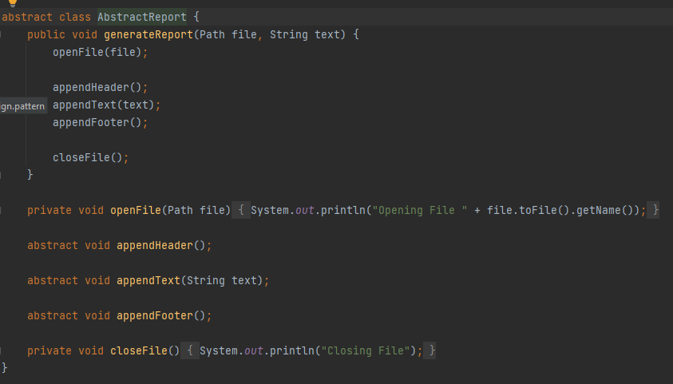

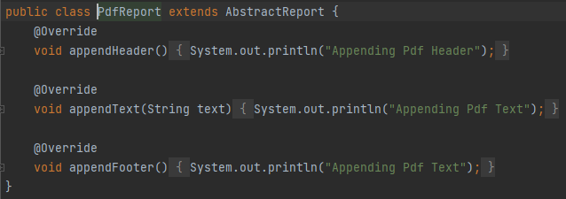

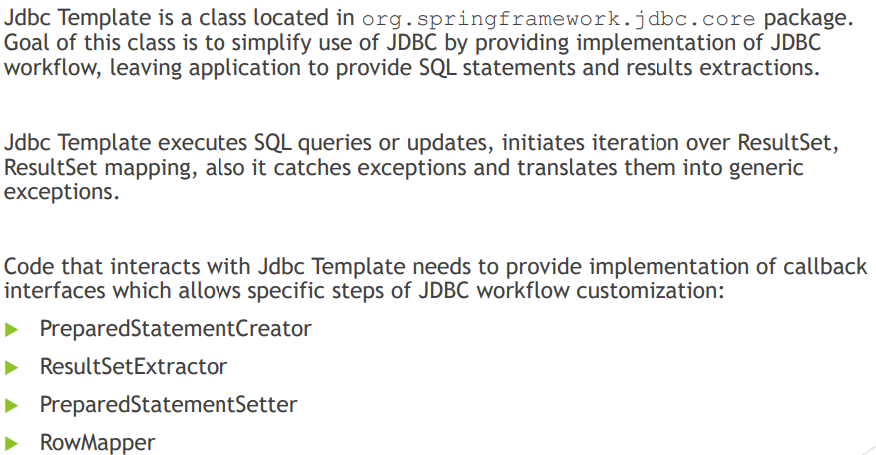

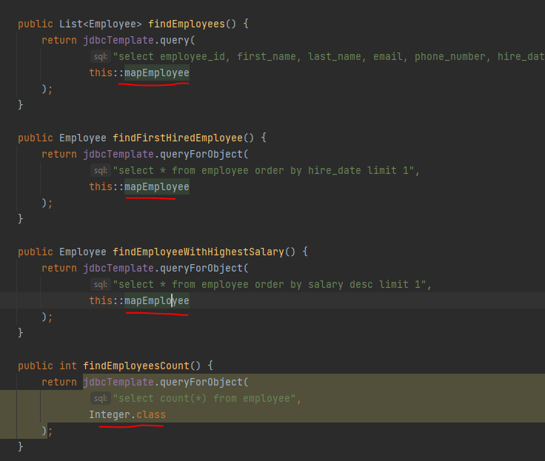

And the mapper method:

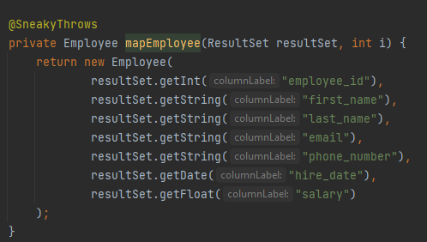

1. **What is the callback?**

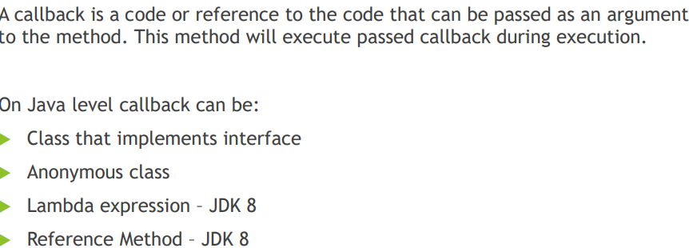

1. **What is the jdbc callbacks?**
2. RowMapper (can be used to map each row)

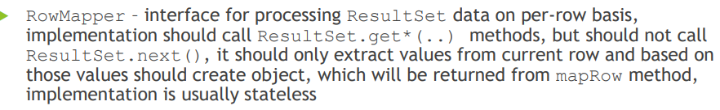

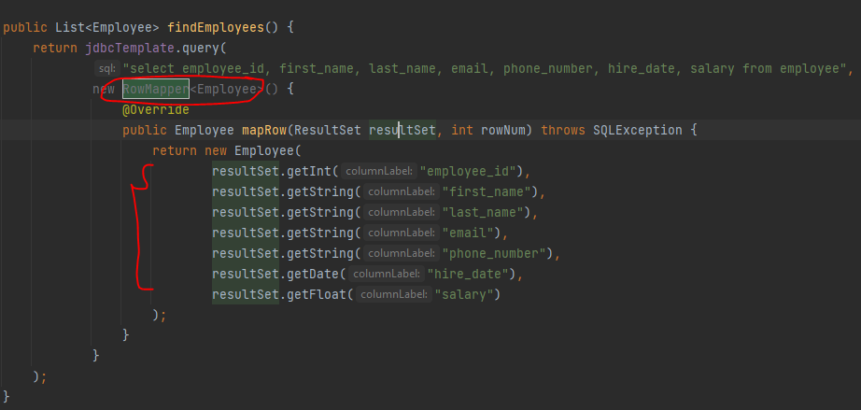

1. RowCallbackHandler: same as previous one but it does not return a value (statefull)

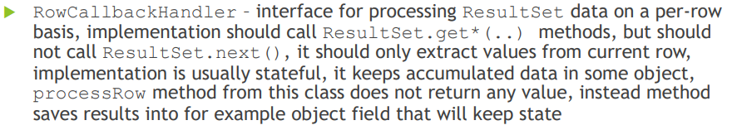

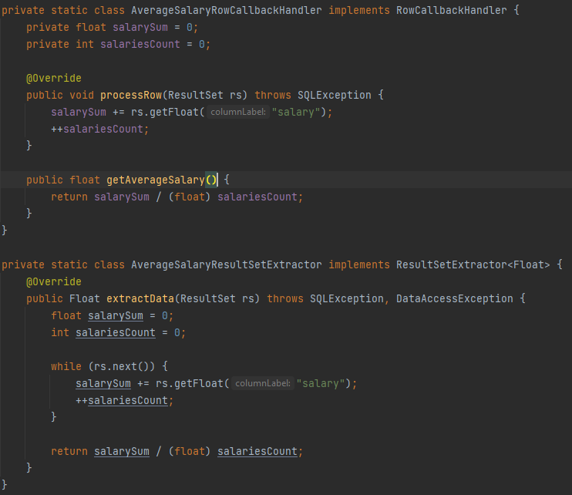

As we can see we store the result in the class fields itself which is the avg in this case,

This makes RowCallbackHandeler statefull coz it dependent on the class fields , stateless will just return the value without saving it.

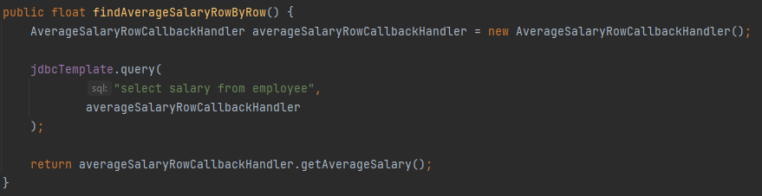

1. ResultsSetExtractor :

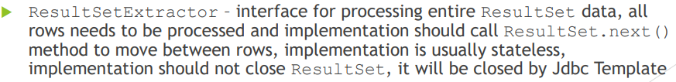

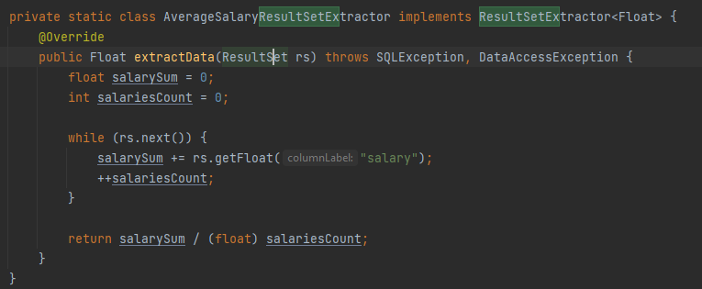

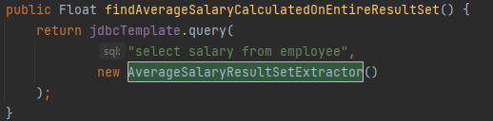

Jdbc have other callbacks:

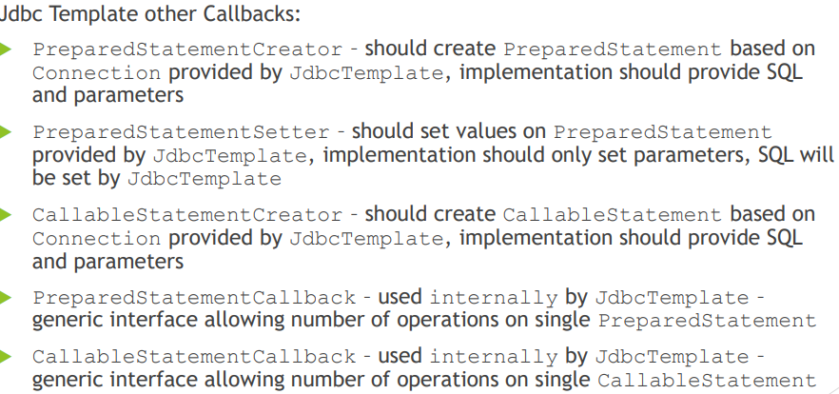

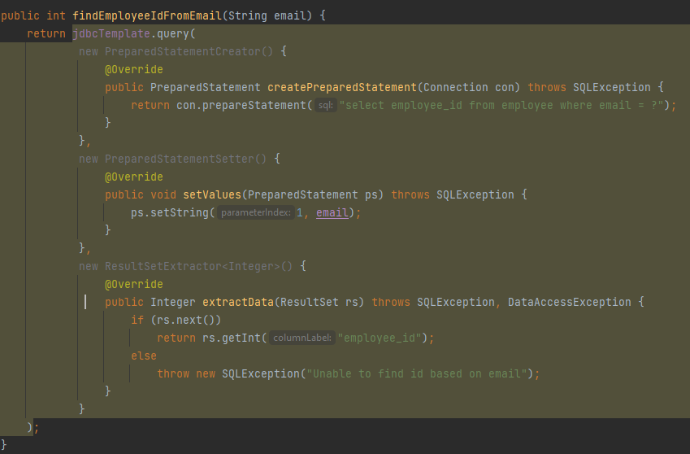

1. **Can you use plain SQL statement with jdbc template?**

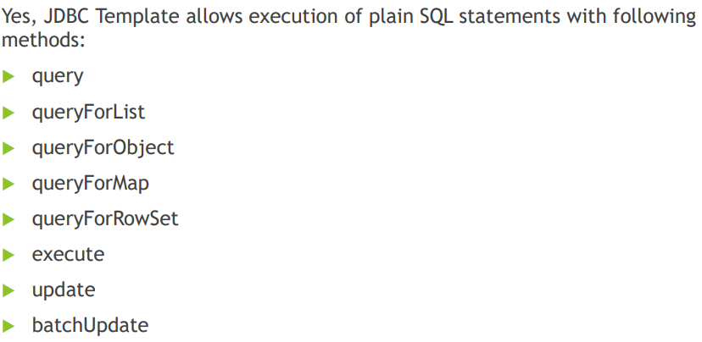

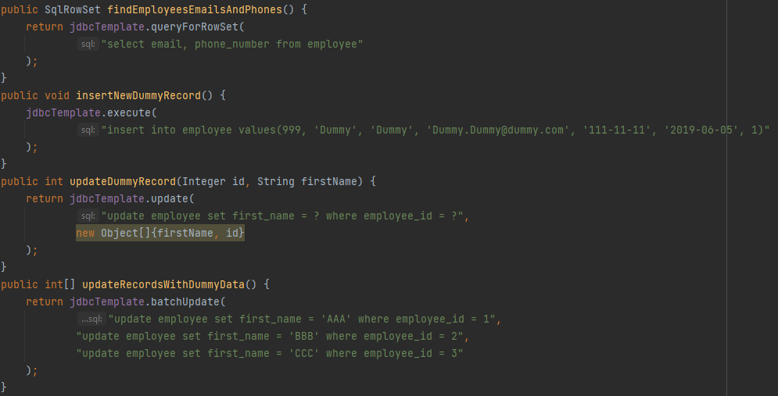

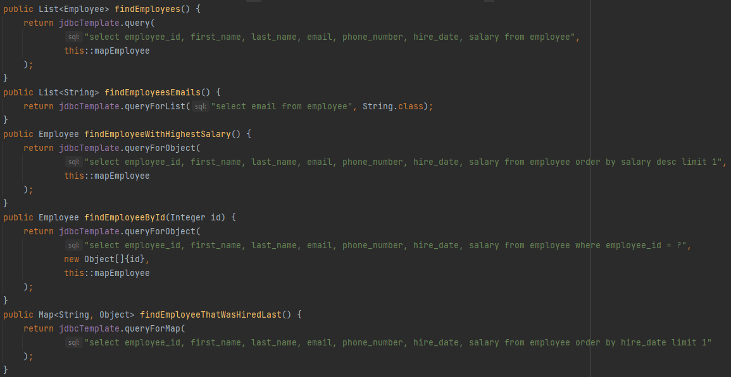

1. **When does JDBC template acquire and release a connection?**

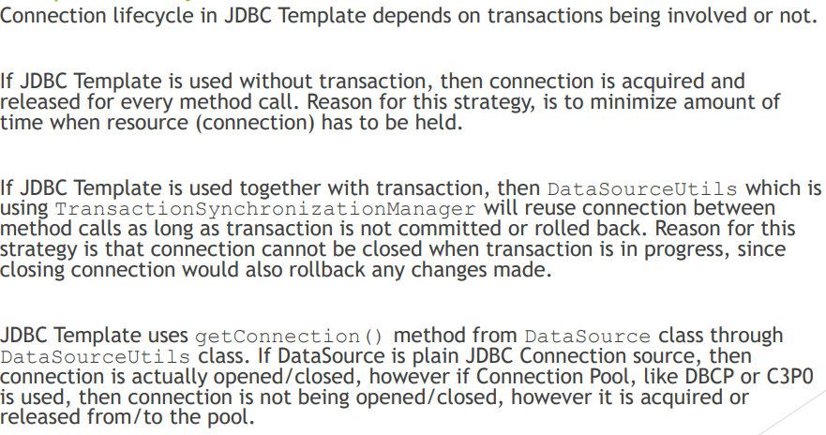

If not using a @transactional then jdbc template will open and close a connection for each call to the db.

If method annotated with @transactionl then all queries inside this method will reuse the same db connection then if all executed successfully then it will commit , otherwise it will rollback in case exception happened.

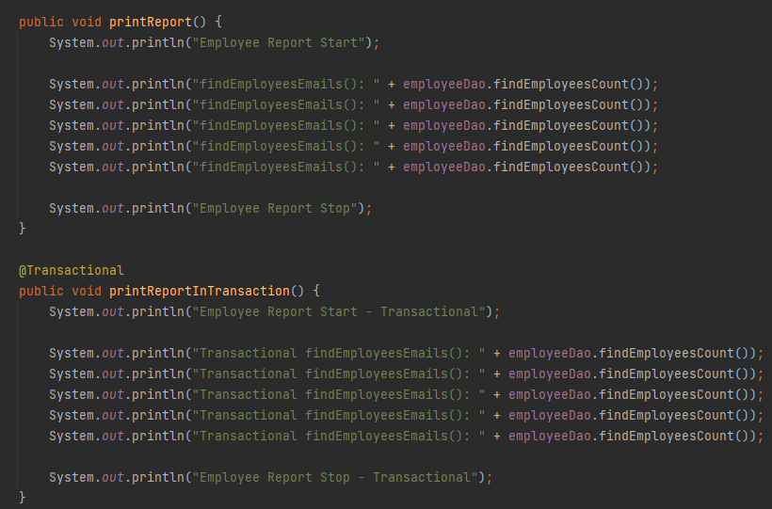

1. **How does jdbcTemplate support generic queries?**

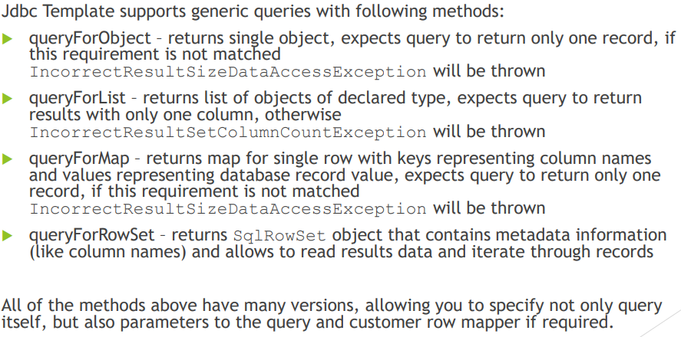

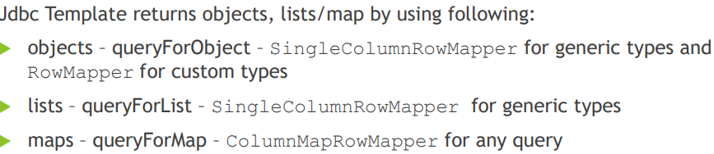

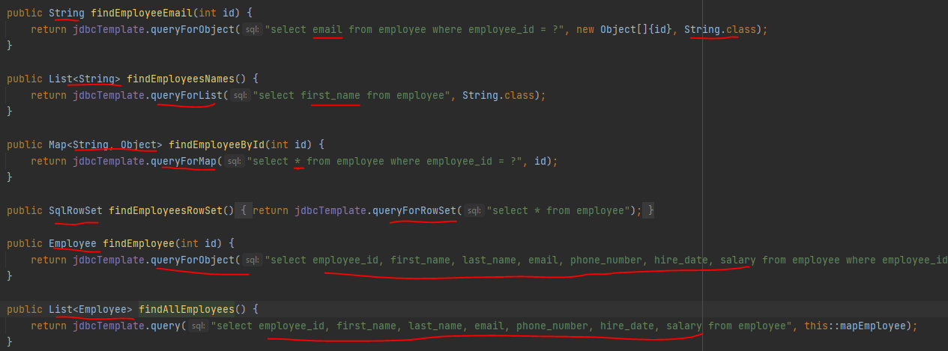

For queryForObject the select query return only one column

For queryForList it should return one column only.

For queryForMap it will return column name+value .

For queryForRowSet it will return SqlRowSet but we should navigate on the list.

For query it will return list of object , but we must provide a mapper.

1. **What is a transaction?**

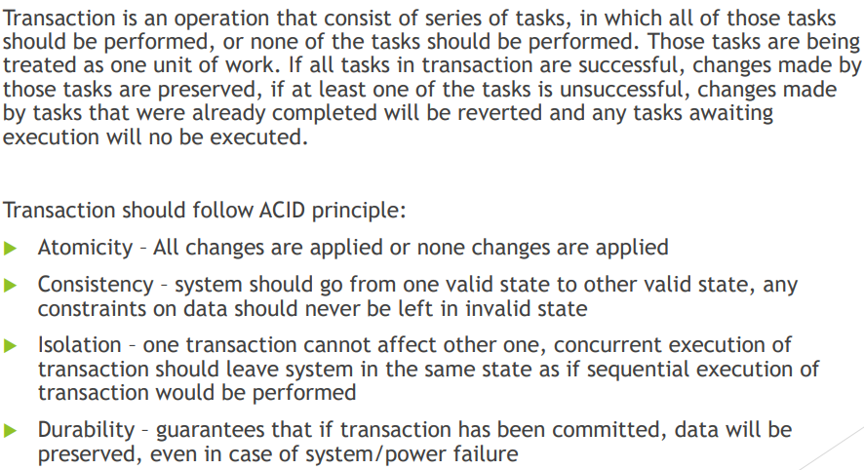

Lets take this example of running insert statements without a transaction, we will notice that once it thro an exception then id 1,2,3 will still in database.

While for @transactional once it thro an exception then all insert will be rolled back inside this method

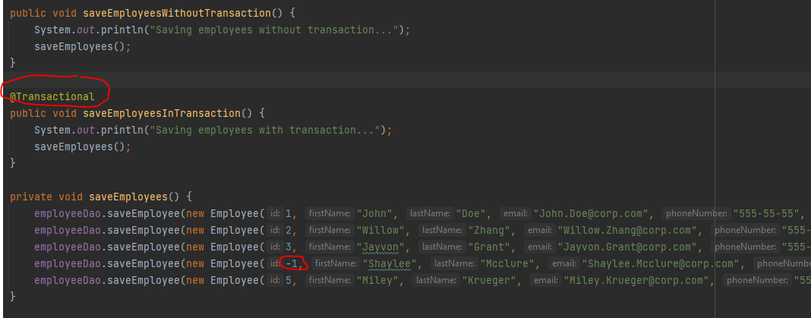

1. **Whats the difference between local and global transaction?**

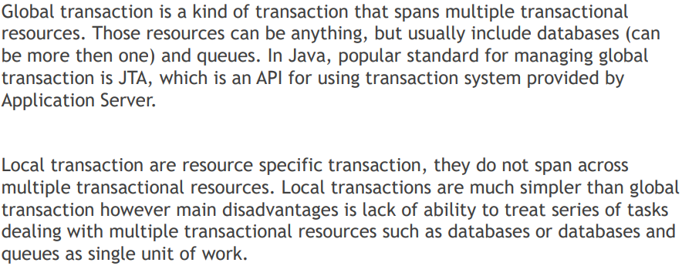

1. **Is a @transactionl is a cross cutting concern? And how it implemented in spring?**

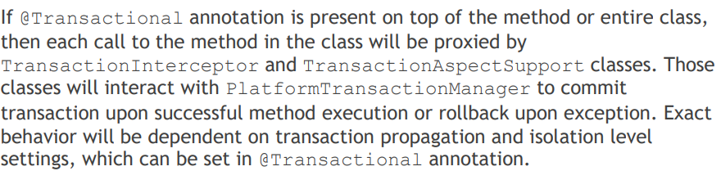

1. **How are you going to define a transaction in spring and spring boot?**

In spring boot u no need to do any additnal works, just need to annotate the method or class with @transactional.

But in standalone spring and web application need to do the followings:

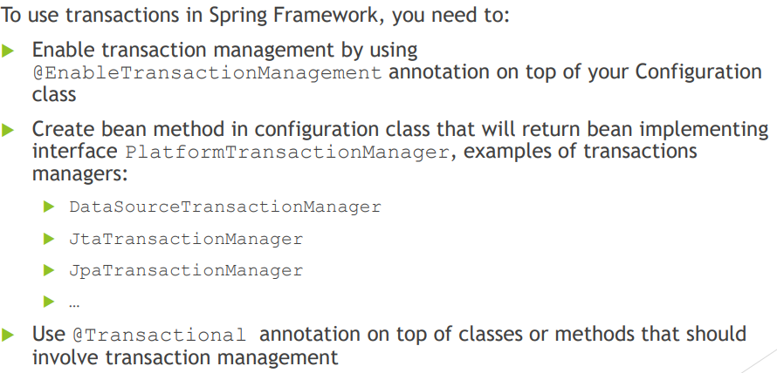

First add @EnableTransactionManagement on config file:

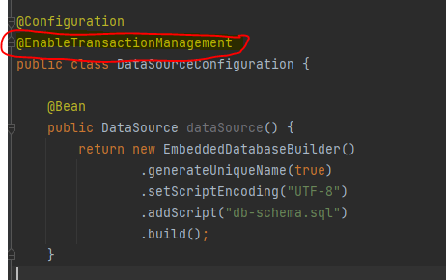

Then add PlatformTransactionManager bean in config:

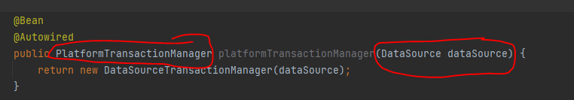

Then add on top of class or method:

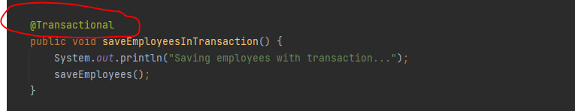

1. **What does @transaction do?**

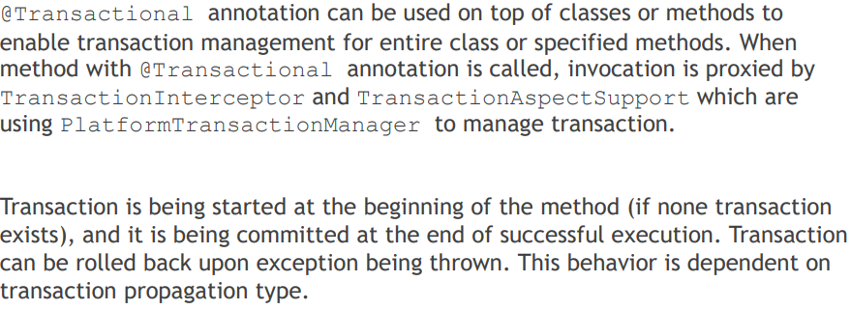

1. **Can we customize the behaviour of @transactional?**

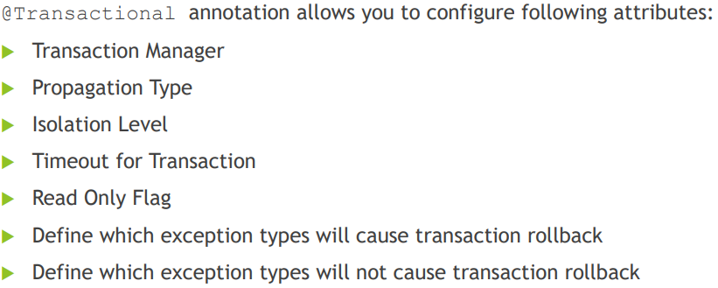

(we will discuss this more in details in later questions)

1. **What is PlatformTransactionManager?**

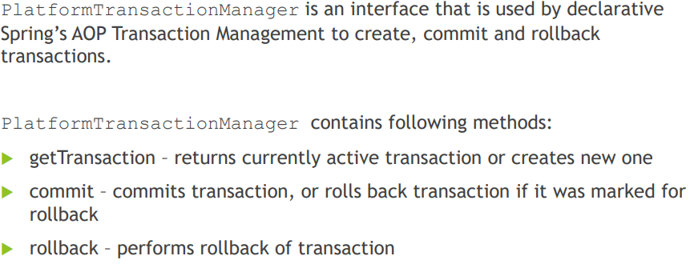

1. **Is the existing jdbc able to participate in an existing transaction?**

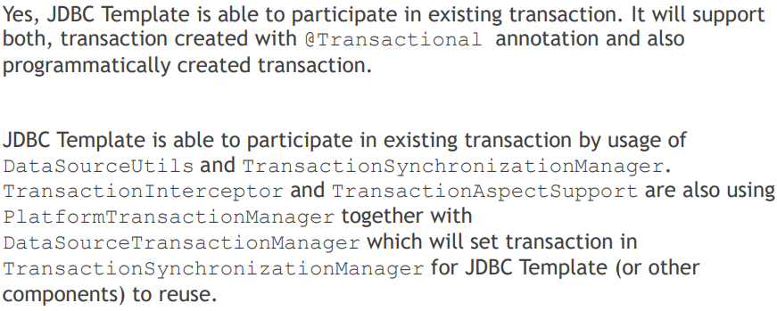

1. **What is the transaction isolation level?**

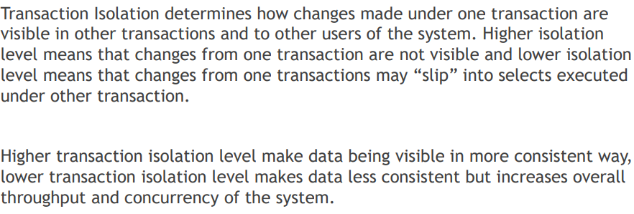

1. **What is the phantom read?**

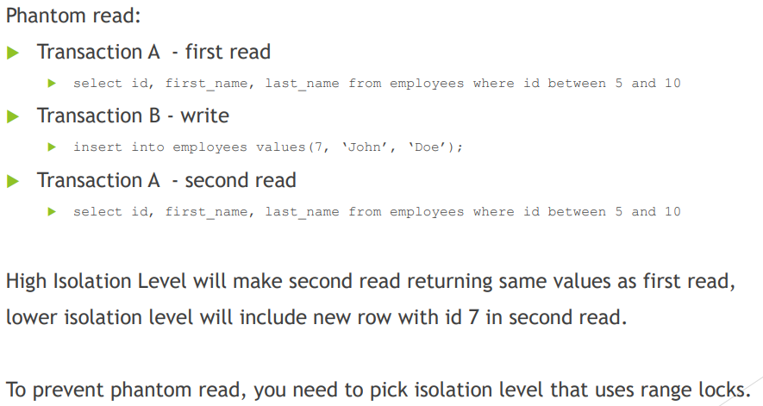

High isolation will acquire range lock so It will prevent the phantom read.

1. **What is the Non-repeatable read?**

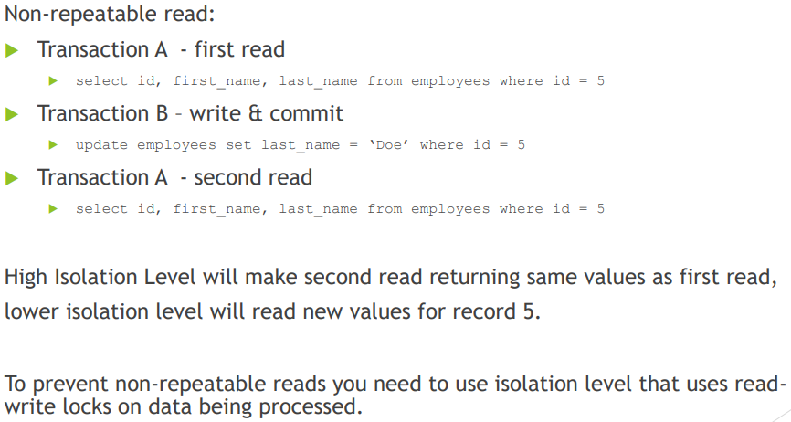

1. **What is Dirty read?**

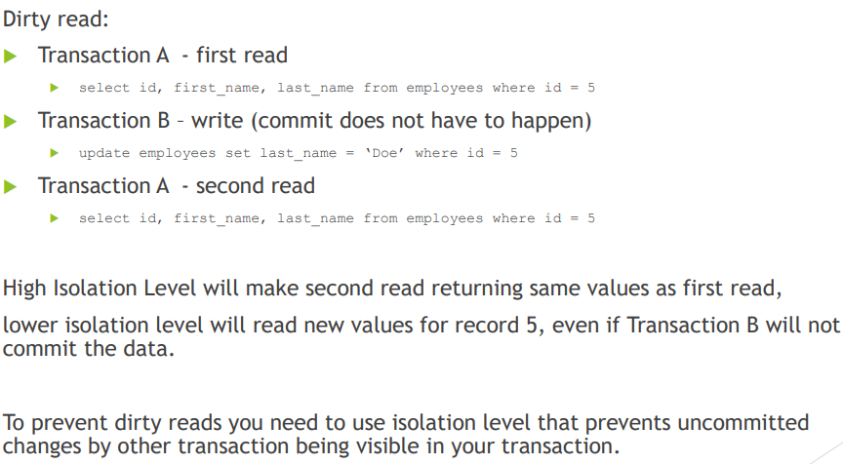

1. **What is the transaction isolation level?**

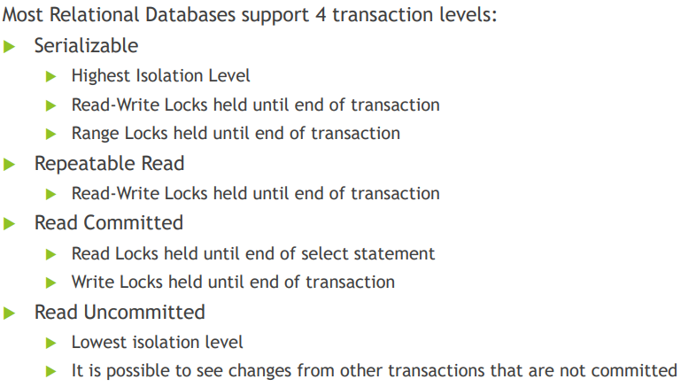

1. Serializable read:

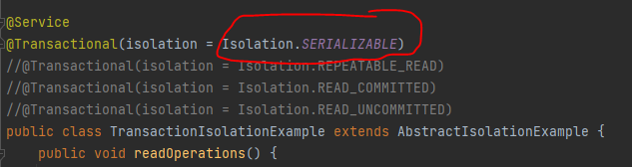

Lets say we have this operations inside this method:

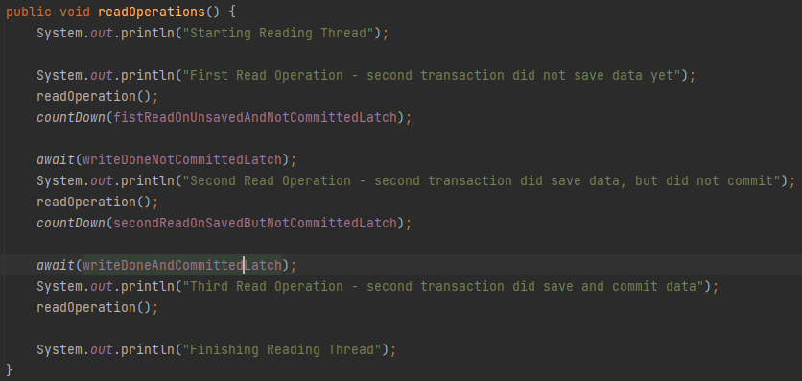

First read operation the results will be:

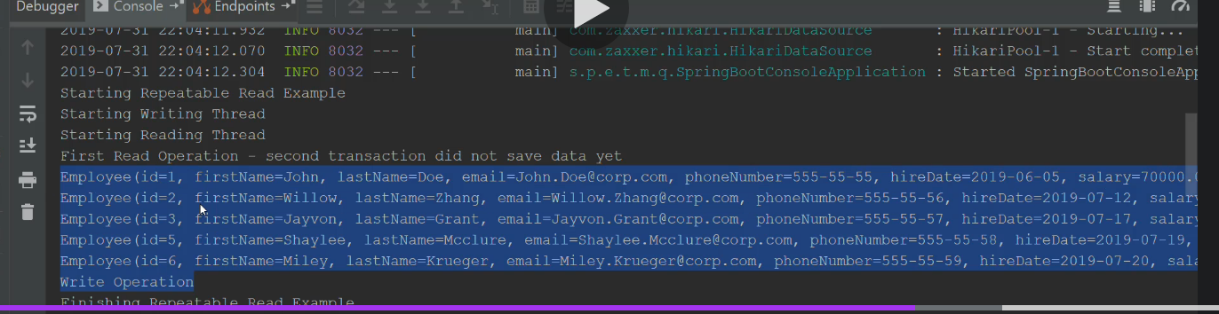

Id= 1,2,3,4,5,6

Then we write to db but without committing the data:

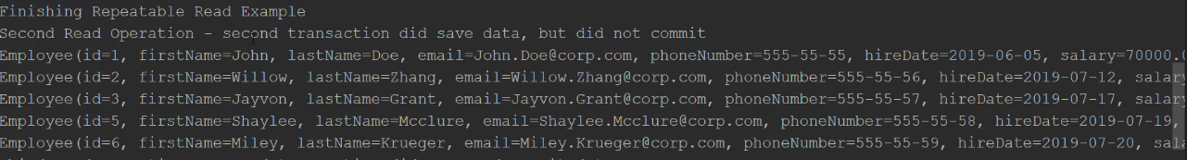

Data still the same coz serializable will not read uncommitted data

Id=1,2,3,4,5,6

Then write and commit the data to db :

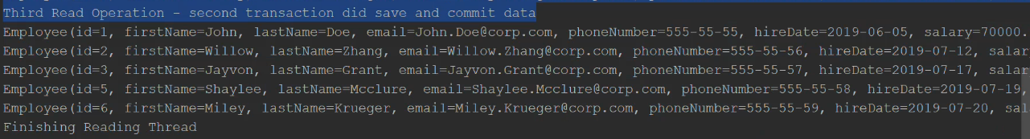

Data still the same bcoz serializable lock will make the data consistent even tho u commit but serializable make sure that no phantom read occur !

Note that serializable will acquire range lock for query between A and B .

Only after the transaction finish then we will able to see the data from different transaction, write operation has to wait for ready operation to finish.

Coz read will acquire range lock so lets say we have ready between 1 and 10 and there is write operation try to insert id 6 then this write has to wait range lock to finish first.

1. Repeatable read:

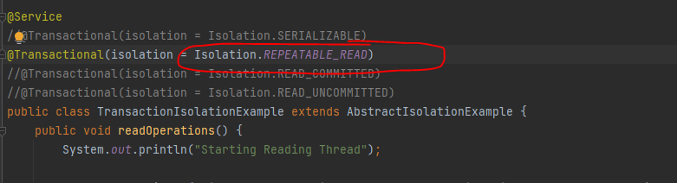

Phantom read may occur in repeatable read

And we don’t have range lock here , means write will not wait the read range to finish.

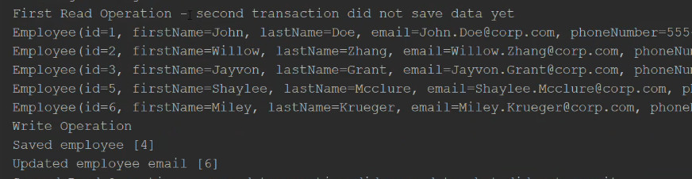

Then we have write operation but without commit :

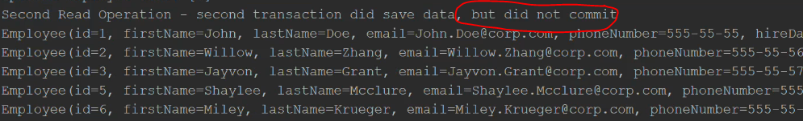

The data will still the same coz repeatable read will not read uncommitted data

Then we write and commit the data and the data still same coz its repeatable read:

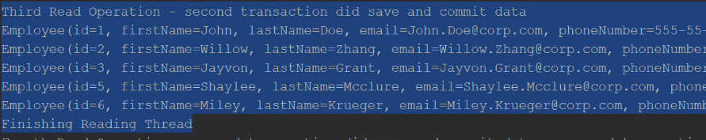

Only after transaction finish then we will be able to see the data:

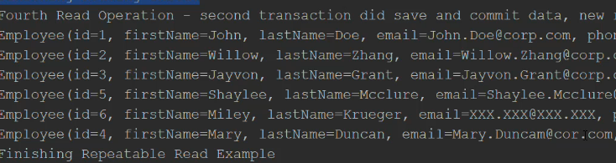

1. Read committed read:

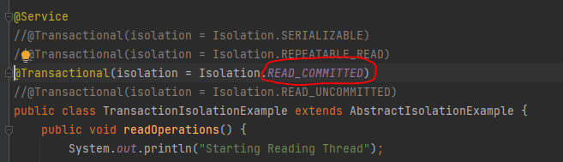

First read operation:

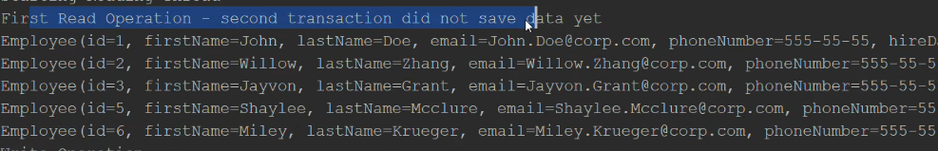

Id=1,2,3,4,5,6

Then after write to db but not committed yet we will still see the same data.

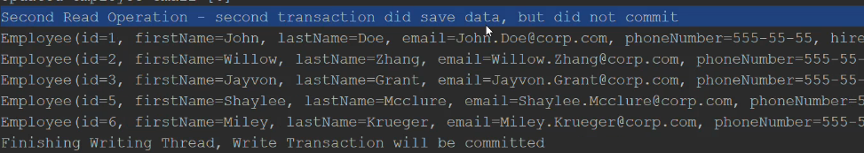

Third read after data been committed to db then we will be able to see the data on read:

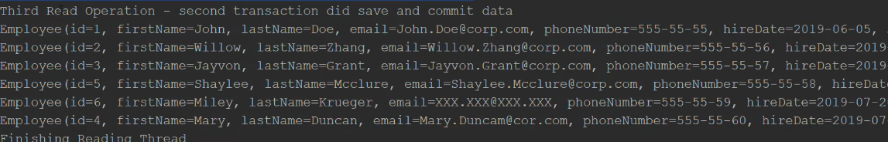

Id=1,2,3,4,5,6

1. Read uncommitted read:

The changes will be visible even tho we didn’t commit the transaction.

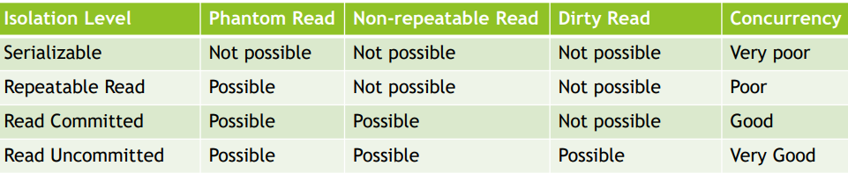

1. **What is @EnableTransactionManagment used for?**

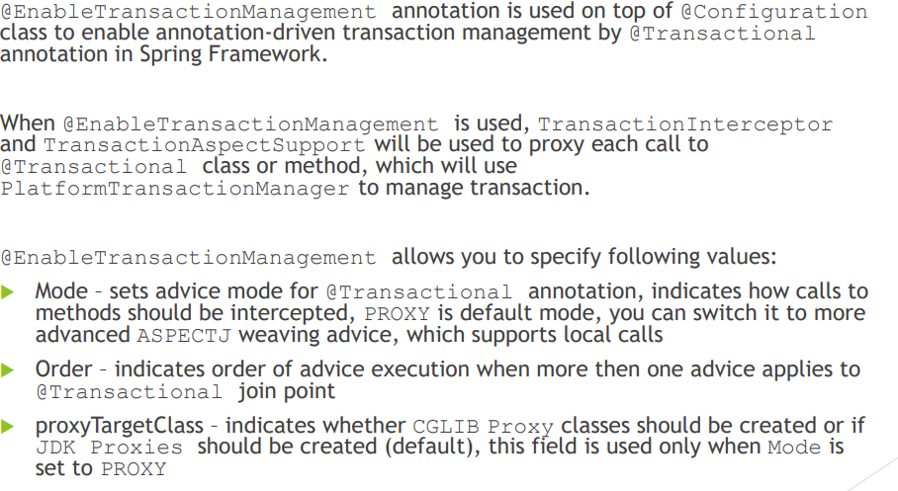

1. **What is the transaction propagation?**

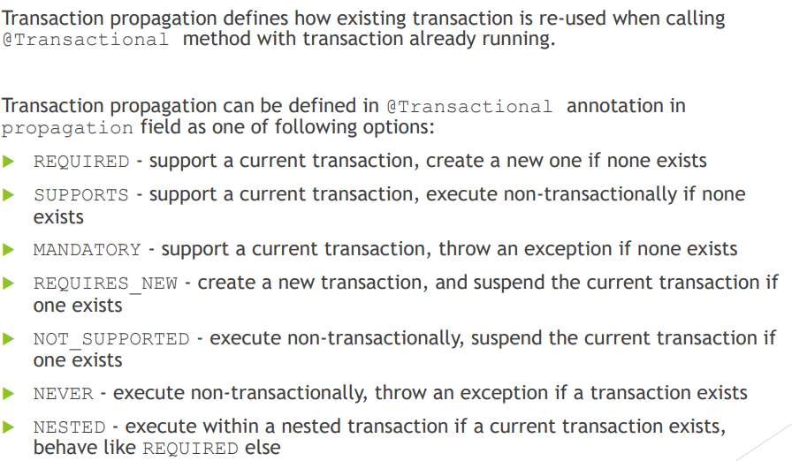

1. Required propagation:

It will create a new transaction if none exists

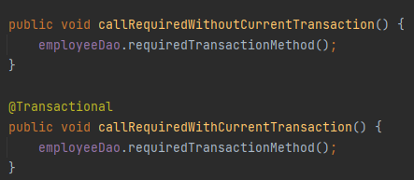

For callRequiredWithoutCurrentTransaction as we can see that this method is not annotated with @Transactional that’s why when it call requiredTransactionMethod it will open a new transaction bcoz no transaction found.

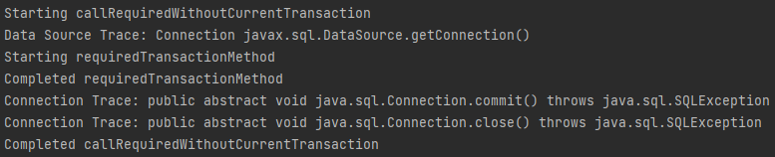

As we can see when It called callReuiredWithoutTransaction id didn’t open a transaction , but call requiredTransactionMethod it open a new transaction bcoz no open transaction found in the callee method.

For callRequiredWithCurrentTransaction it will open a new transaction bcoz its annotated with @transactional and it will reuse this transaction in requiredTransactionMethod and it will not open a new one.

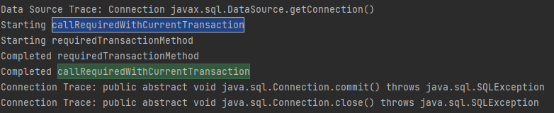

As we can see that the transaction opened once only at the first method but for requiredTransactionMethod it didn’t open a new transaction it will just reuse the callee transaction.

1. Support propagation:

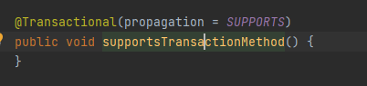

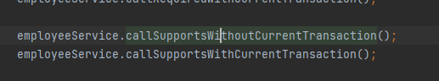

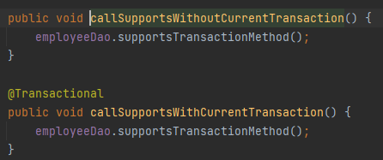

For callSupportsWithoutCurrentTransaction it will not open a new transaction if none found from the callee.

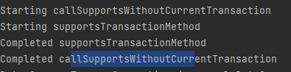

For callSupportsWithCurrentTransaction its annotated with @transaction so it will open a transaction and the method inside will just reuse this transaction

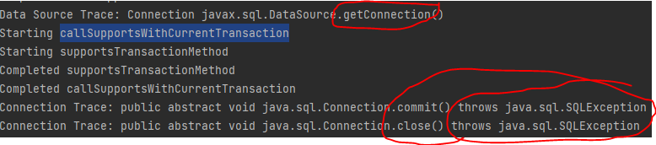

1. Mandatory propagation:

It will support a current transaction and it will thro an exception if transaction not opened. Means u must annotated the method with @transaction to call mandatory propagation

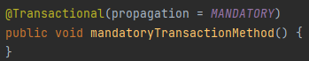

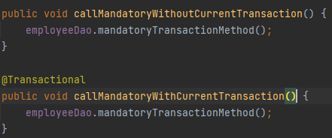

For first method it will thro an exception bcoz its not annotated with @transactional

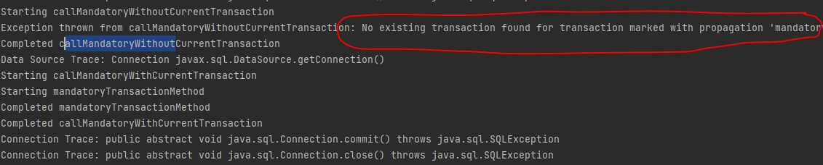

For the second method its annotated with @transaction so it will works and will open a new transaction and the method inside will just reuse the same transaction

1. Requires new propagation:

It will create a new transaction and suspend the current if one exists

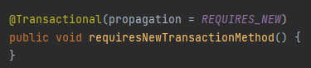

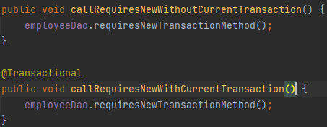

For first method it will call the inside method and the inside method will open a new transaction always.

For the second method it will open a new connection and wont reuse the existing one.

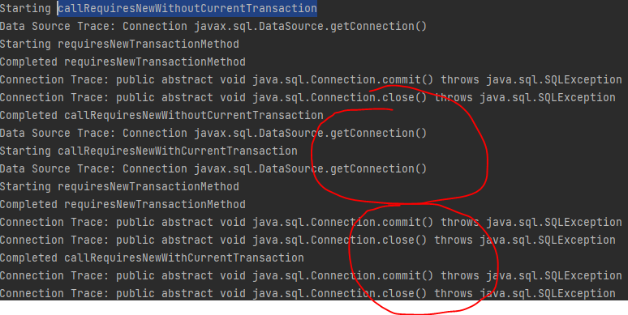

1. Not supported propagation:

It will execute non transactionall and will suspend the current transaction if one exists

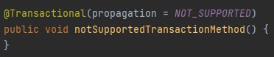

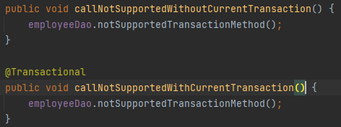

For the first method it will not open any transaction even the inside method employeeDao.notSupportedTransationMethod() it will not open a transaction coz the callee didn’t open.

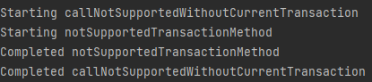

For the second method as we can see its annotated with @Transaction so it will open a new transaction but inside this method we call employeeDao.notSupportedTransationMethod() which is annotated with not_supported propagation so this employeeDao.notSupportedTransationMethod() will suspend the callee transaction and this method employeeDao.notSupportedTransationMethod() will be executed in a **non-transactional mode** .

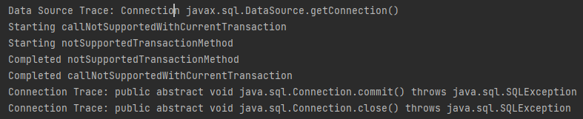

As we can see that method notSupportedTransationMethod() has been executed in non-transactionl mode and didn’t open any transaction .

Refe: <https://www.baeldung.com/spring-transactional-propagation-isolation>

1. Never propagation :

It will execute only in non-transactional mode and it will thro an exception if u try to call from a transaction method

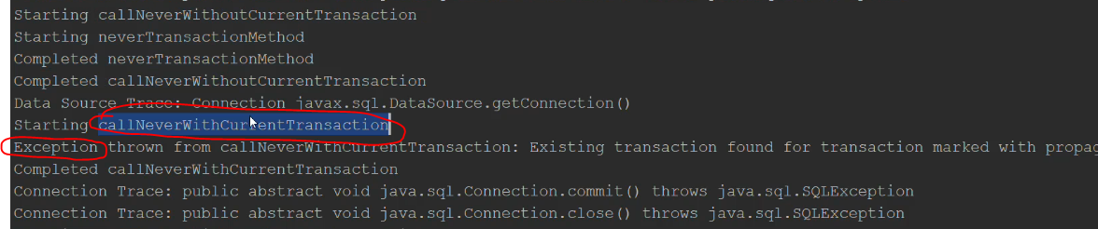

1. Nested propagation:

Its same as required propagation

1. **What happens if one @Transaction method is calling another @Transactional method in same class?**

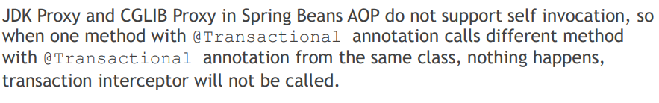

In spring proxy as we can see the config will be:

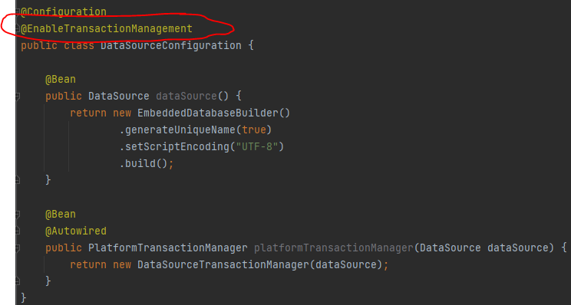

And we have method transaction1And2() is not annotated with @transactional so we will notice that the proxy will not work and it will not open a transaction for this transaction1() and transactio2() methos (even tho thos two method annotated with @transactional)

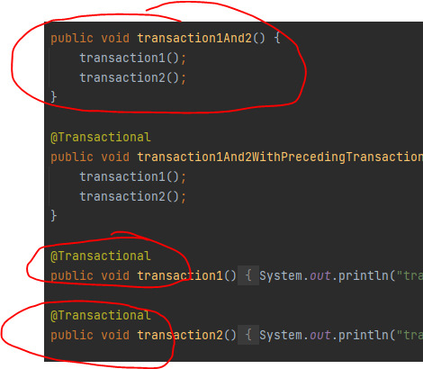

And the results will be no open transactions:

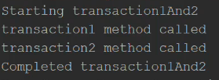

Bcoz it doesn’t not support self invocation

So to support self invocation we need to enable **aspectj** option , so to do so we need to do the following:

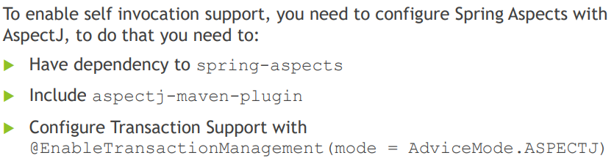

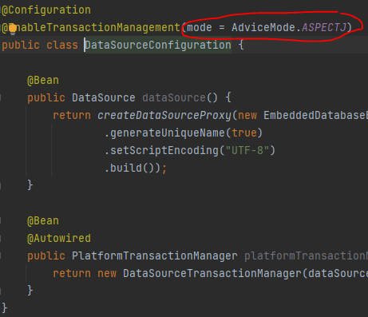

And the results will be:

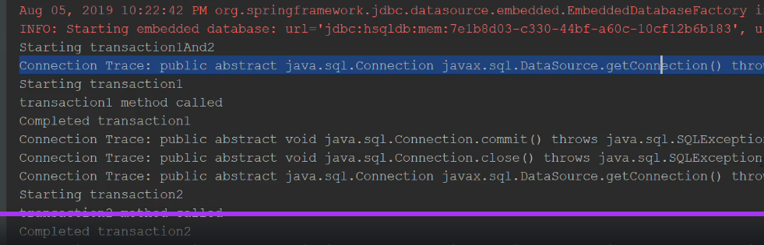

As we can see that for transaction1() and transaction2() it did open a new transaction for each method and we can see that self-invocation supported here.

1. **Where can @Transctional method applied?**

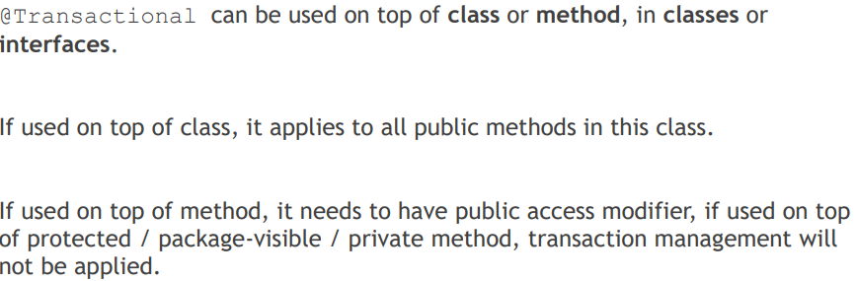

1. **What does declarative transaction management mean?**

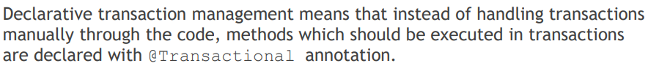

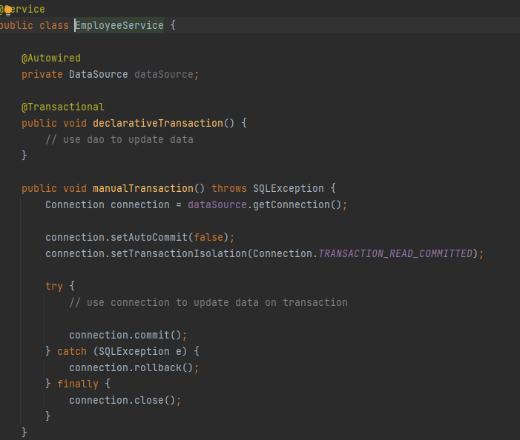

1. **What is the default rollback policy? How can you override it?**

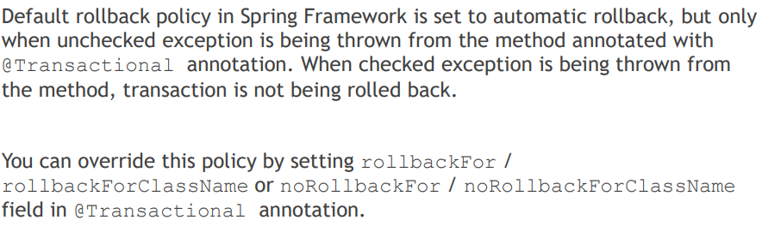

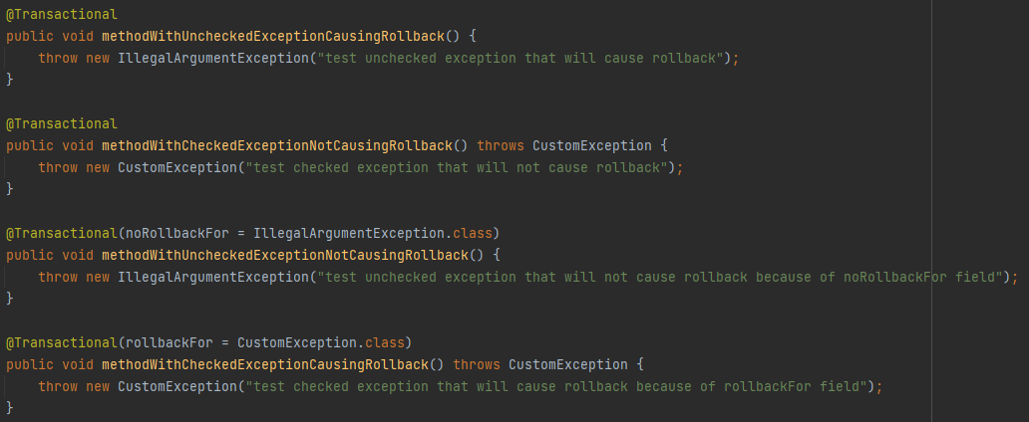

For first method it will cause a rollback coz its unchecked exception.

For second method it will not cause rollback coz its checked exception

For third method it will not cause rollback bcoz we customized the noRollbackFor =

For fourth method will cause rollback coz we customized the rollbackFor.

1. **What is the default rollback policy in a JUnit test, when you use the @RunWith(SpringJUnit4ClassRunner.class) in JUnit 4 or @ExtendWith(SpringExtension.class) in JUnit 5, and annotate your @Test annotated method with @Transactional?**

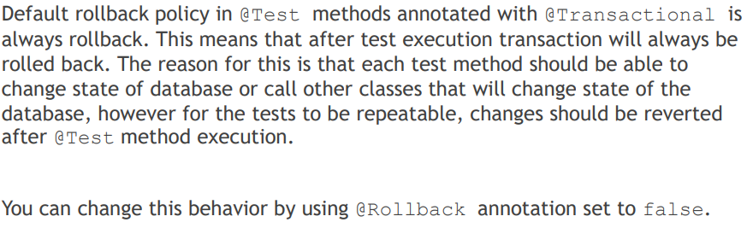

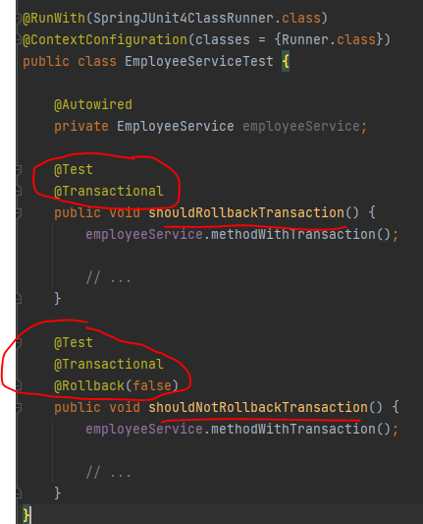

1. **Why is the term "unit of work" so important and why does JDBC AutoCommit violate this pattern?**

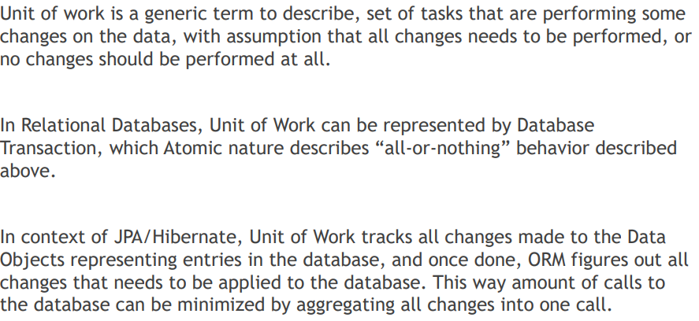

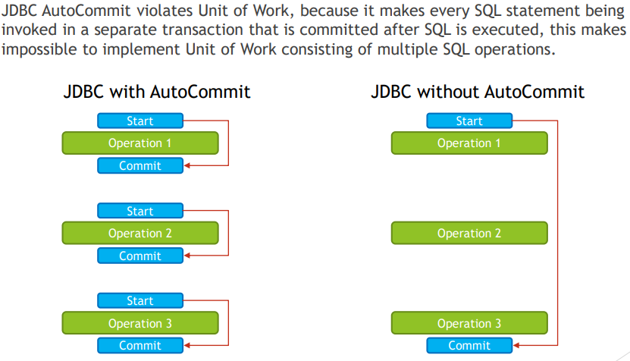

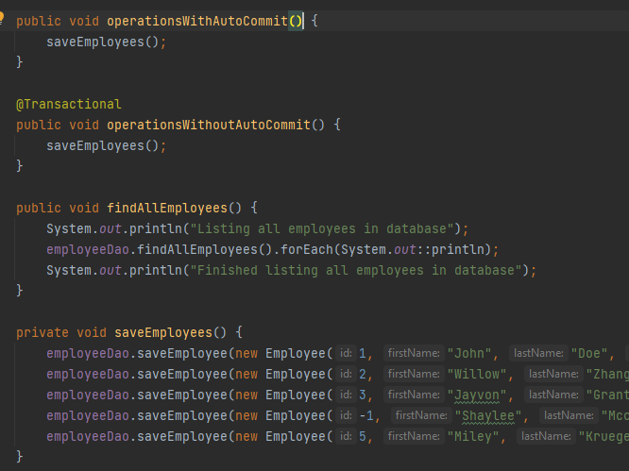

Notice that for method operationsWithAutoCommit it will use autocommit and will save changes to DB with every transaction and that’s why when saveEmployees thro an exception it wont be able to rollback changes from the DB

For operationWithoutAutoCommit its annotated with @Transaction that’s why autocommit is false.

1. **What do you need to do in Spring if you would like to work with JPA?**

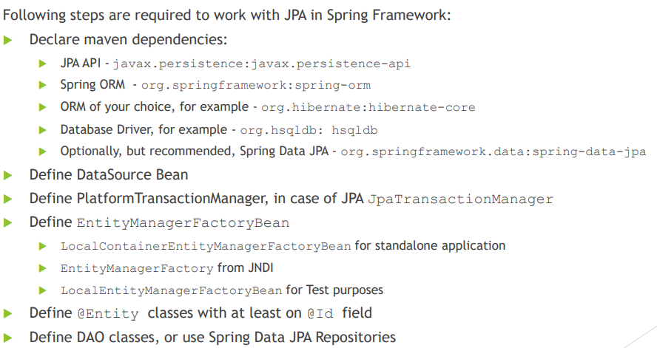

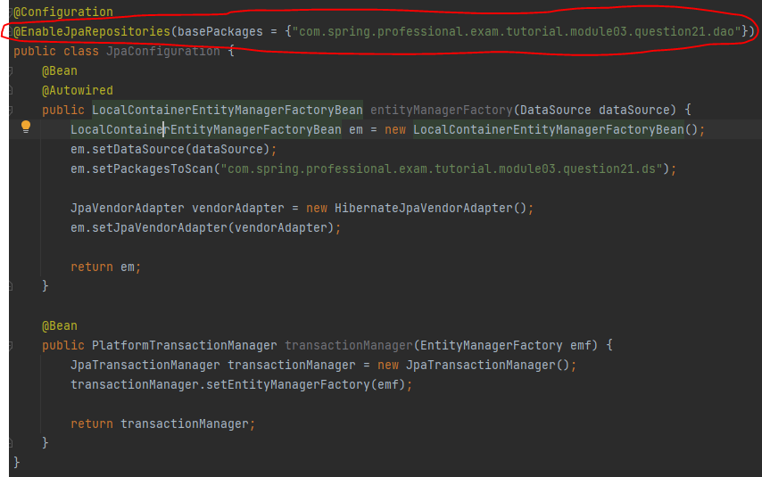

@EnableJpaRepostires will do the implementation of dao interface so I don’t have to implement it.

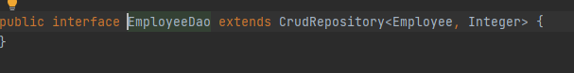

1. **Are you able to participate in a given transaction in Spring while working with JPA?**

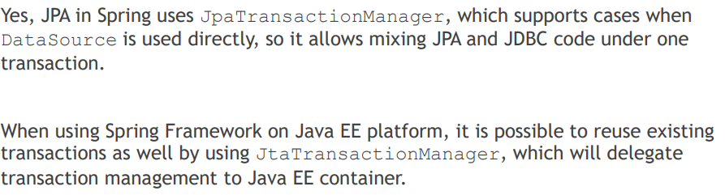

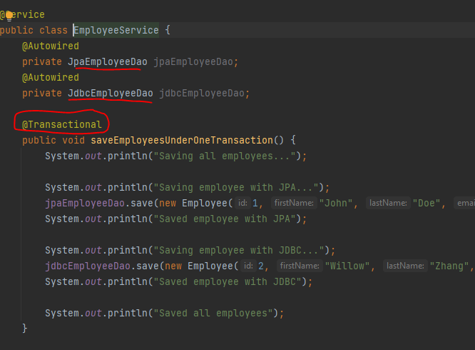

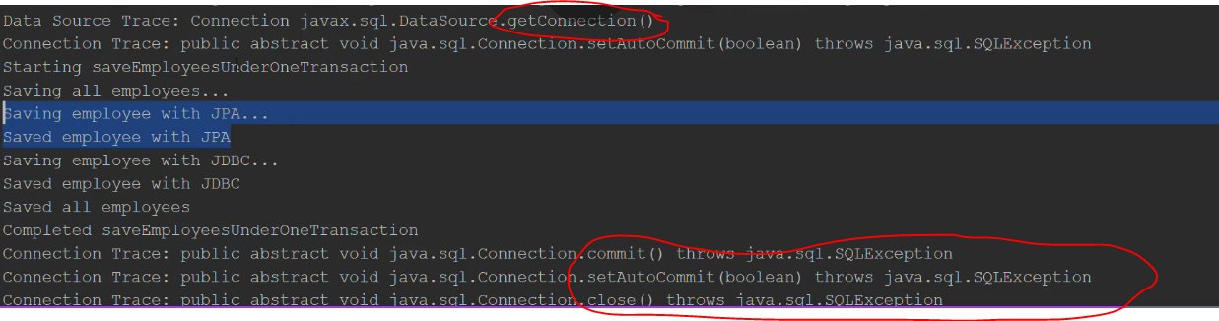

As we can see that it did open one transaction for both jdbc and jpa transaction and jdbc and jpa just reuse the same transaction.

1. **Which PlatformTransactionManager(s) can you use with JPA?**

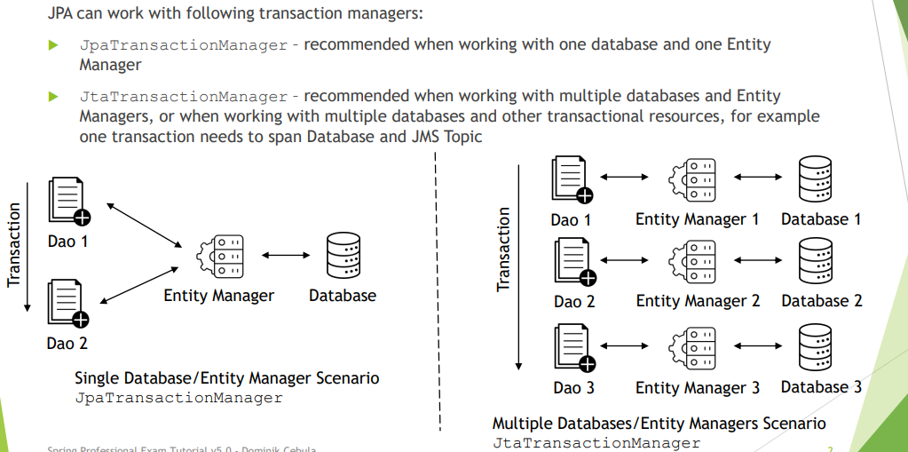

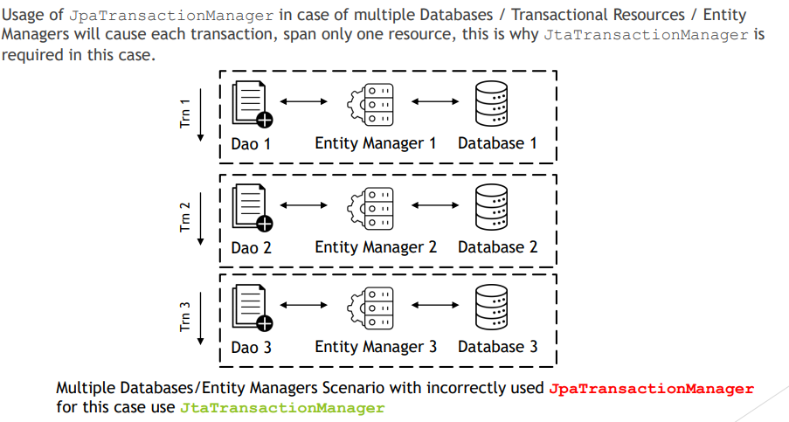

Let take this example when u have two DB , lets say first case u use jpa and second jta:

* jpa:

we will have two configuration for the DB one for emplyees and one for products

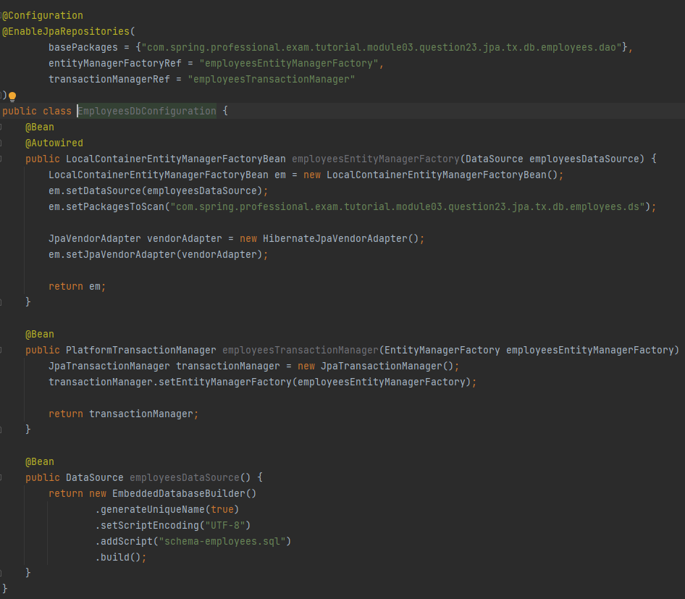

Products config:

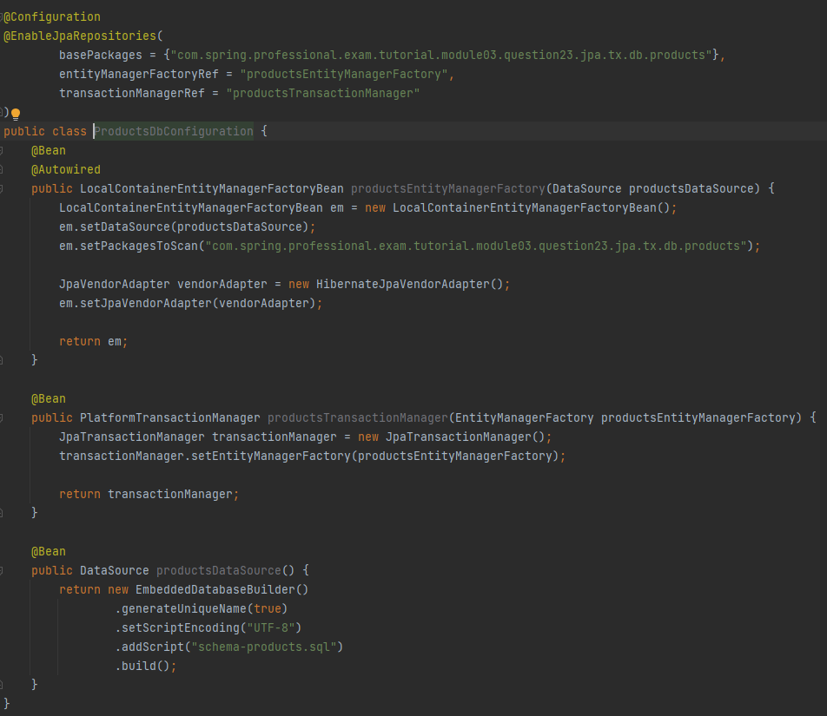

And lets say we have two 2 transaction one for employee and second for product

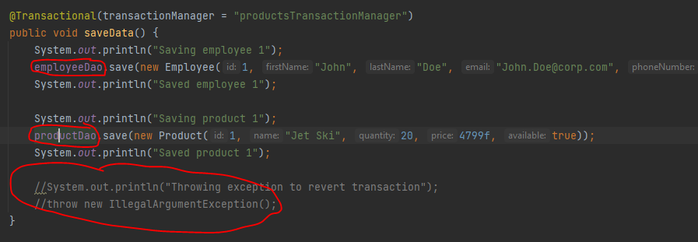

In case exception thro then there is no rollback and the data will still committed to DB.

We will notice that employee data is still in db and only product data will be rollback

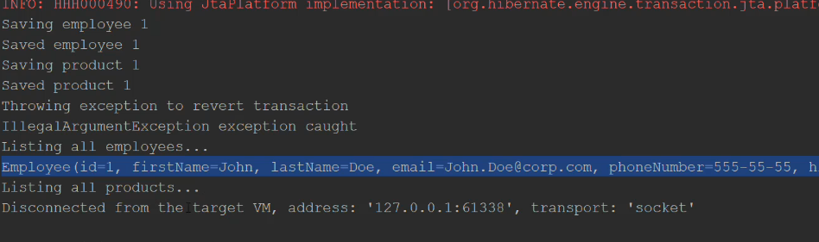

* jta :

we will have 3 configs , one for emplyeee and one for product and one for jta config

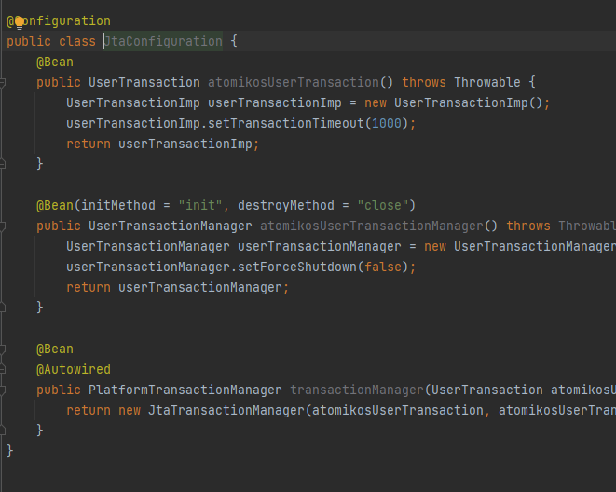

We will notice that if exception thrown then both of the transaction from two different DB will be rollback.

1. **how to configure jpa in spring boot?**

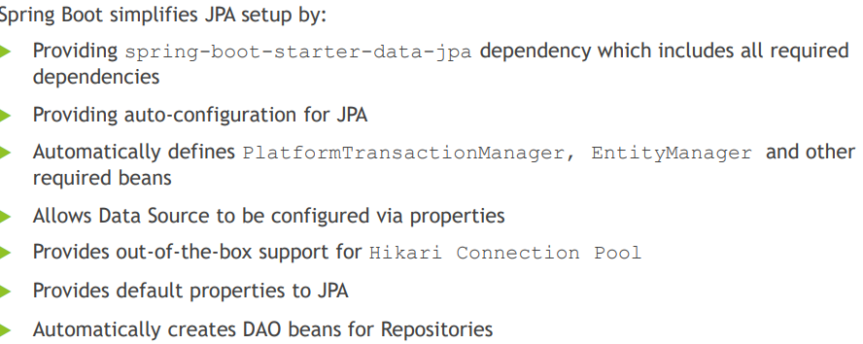

1. **What is a Repository interface?**

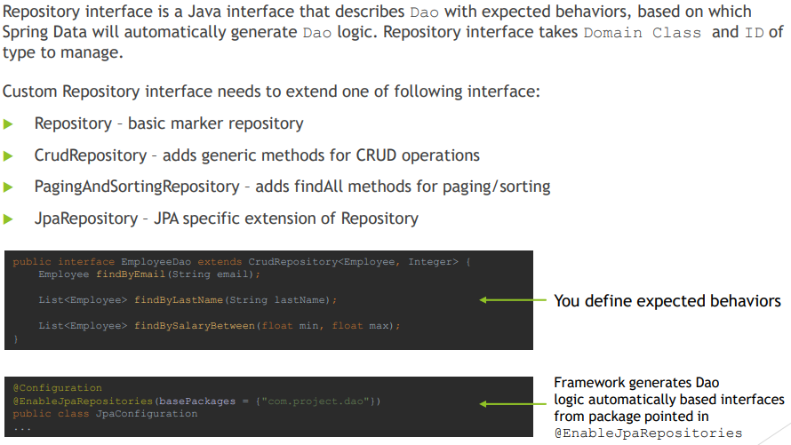

1. **How do you define a Repository interface? Why is it an interface not a class?**

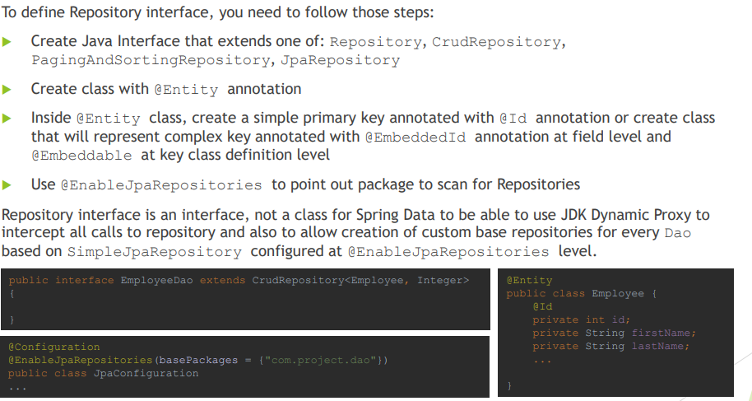

1. **What is the naming convention for finder methods in a Repository interface?**

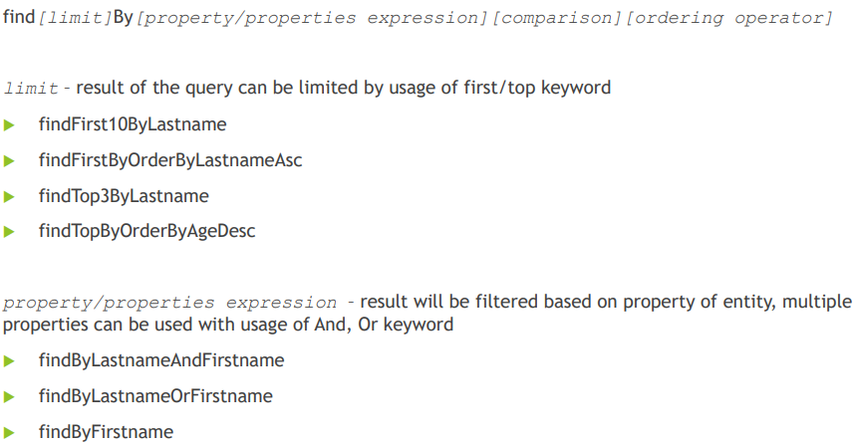

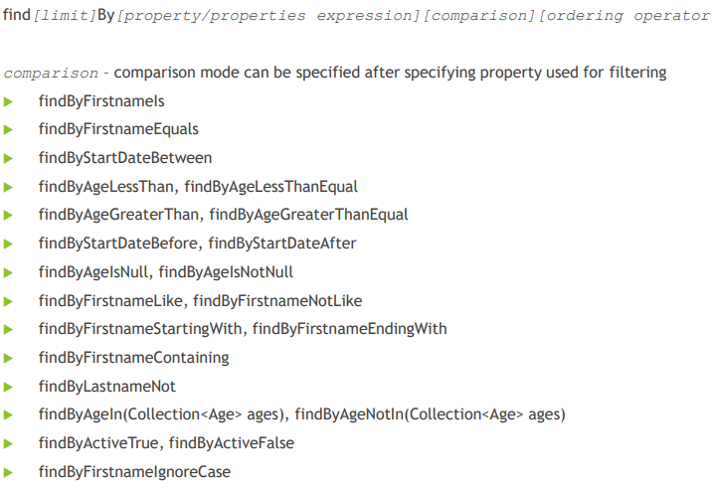

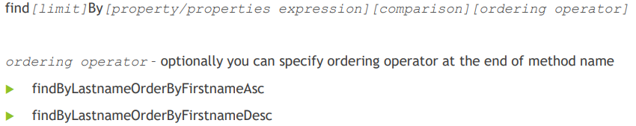

1. **How are Spring Data repositories implemented by Spring at runtime?**

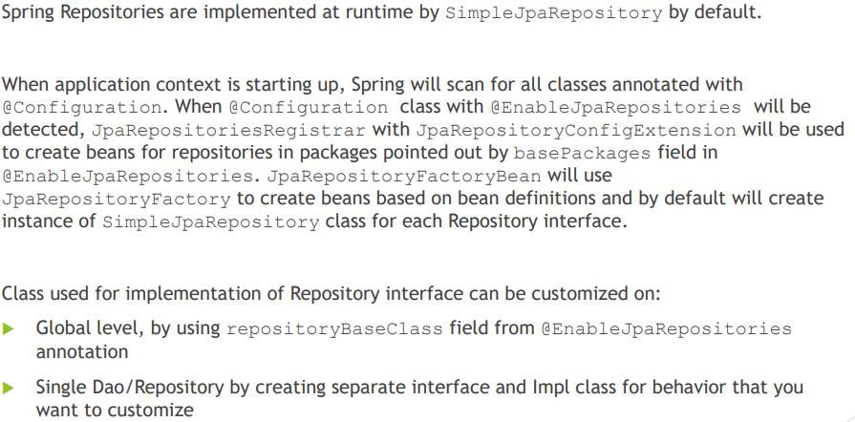

1. **What is @Query used for?**

